**Temp Data In Asp.Net Mvc**

* TempData is a Dictionary object derived from the TempDataDictionary class.
* TempData stores data as key-value pairs. TempData[“Var”] = “Adil”
* TempData value must be type cast before use. Check for null values to avoid runtime error.
* TempData allows passing data from the current request to the subsequent request during request redirection.

**The general syntax of TempData is as follows:**

where,

TempData[<Key>] = <Value>;

**Key**: Is a String value to identify the object present in TempData.

**Value:** Is the object present in TempData.

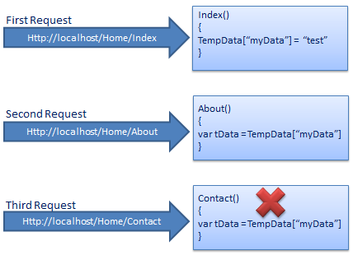

* **TempData** in ASP.NET MVC can be used to store temporary data which can be used in the subsequent request. **TempData** will be cleared out after the completion of a subsequent request.
* Call TempData.Keep() to keep all the values of TempData in a third request.